**Races**



Humans

These are common throughout each location because each planet you can visit has a galactic highway stop. They likes all snacks.



Pleni

These are rare on most planets, except, of course, when on their planet, where they are more than common. They likes the taste of Salty and Sour snacks, but mostly dislike Savory and Sweet.



Space Squid

The squid are rare, hardly coming down from their space houses. But when they do they like to eat Savory snacks, and also dislikes most Salty ones.



Humming Exoskeletons

These humming-bird like creatures zip from one interesting thing to the next, but are banned from Plenus. They come in a variety of colors.. They like Sour and Sweet snacks, and have no dislikes.



Floor Robots

It’s common to see one of these rolling around, beeping and booping at people. They like Salty snacks, and shy away from Sour and Sweet.



Large Blobs

These are somewhat uncommon, but when two meet, they want to merge into a bigger one. They are polyamorous, but sometimes split up. The like Sour snacks, and stay away from the rest.

**Economy**



AI (races) & Vending Machines

As AIs pass by, they have a chance of stopping at one of your vending machines, then, based off their likes and dislikes, they have a chance to *Purchase* something, depleting a bit of the vending machine’s stock, and putting money in its holder. They may also *Vandalize* it, potentially removing an upgrade, breaking it (putting it out of order until you repair it - AI ignore it at this point), or defacing it (reducing the chance for an AI to stop at the vending machine to purchase). They may also *Rob* it (depending on the planet’s laws), reducing some-to-all of the money in the holder; and they might, but less likely, break it during a robbery. *(?)If you witness a robbery you may call the police and are rewarded(?).

You have to manually collect the money by visiting the vending machine and transferring it to your account (action button). You too can manually check the log and stock of your vending machine (action button).

Costs

Your vending machines cost 500 dollars to place and initially holds 1 stock. 1 stock counts for about 10 purchases from AIs. If the vending machine is vandalized or broken, it costs anywhere from 100 - 450 to fix it.



Upgrades

-More stock, cost 100, up to 6 stocks. *2 columns, 3 rows.

-Alert when a stock is depleted, cost 250 *Sends a message to the terminal for a few seconds, then is gone.

-Alert when damaged, cost 500 *Sends a message to the terminal for a few seconds, then is gone.

-Remote Log Feed, cost 1000 *Can check at any time by accessing the device (a button), maybe costs money each use.

-Advertising (Increases chance for AI to check to buy something. Increases chance for it to be vandalized or robbed), costs 100 for each stock slot, so 100 if you have 1 stock, and 600 if you have 6 stock slots. It lasts until stock is gone. *Cool logo appears above the machine

-Protection, cost 250, decreased chance for AI to rob your machine *Tinted yellow, bullet proof glass.

Stock

There are 4 flavors of stock: Savory, Sweet, Sour, & Salty. Each race has a propensity for one or more of the flavors, and will be more willing to purchase that flavor snack. View your stock at any time by accessing your terminal.

The first graph show how many likes and dislikes each stock flavor has. The second graph, based off the commonality of each race, show how popular or likely stock in general will be bought.

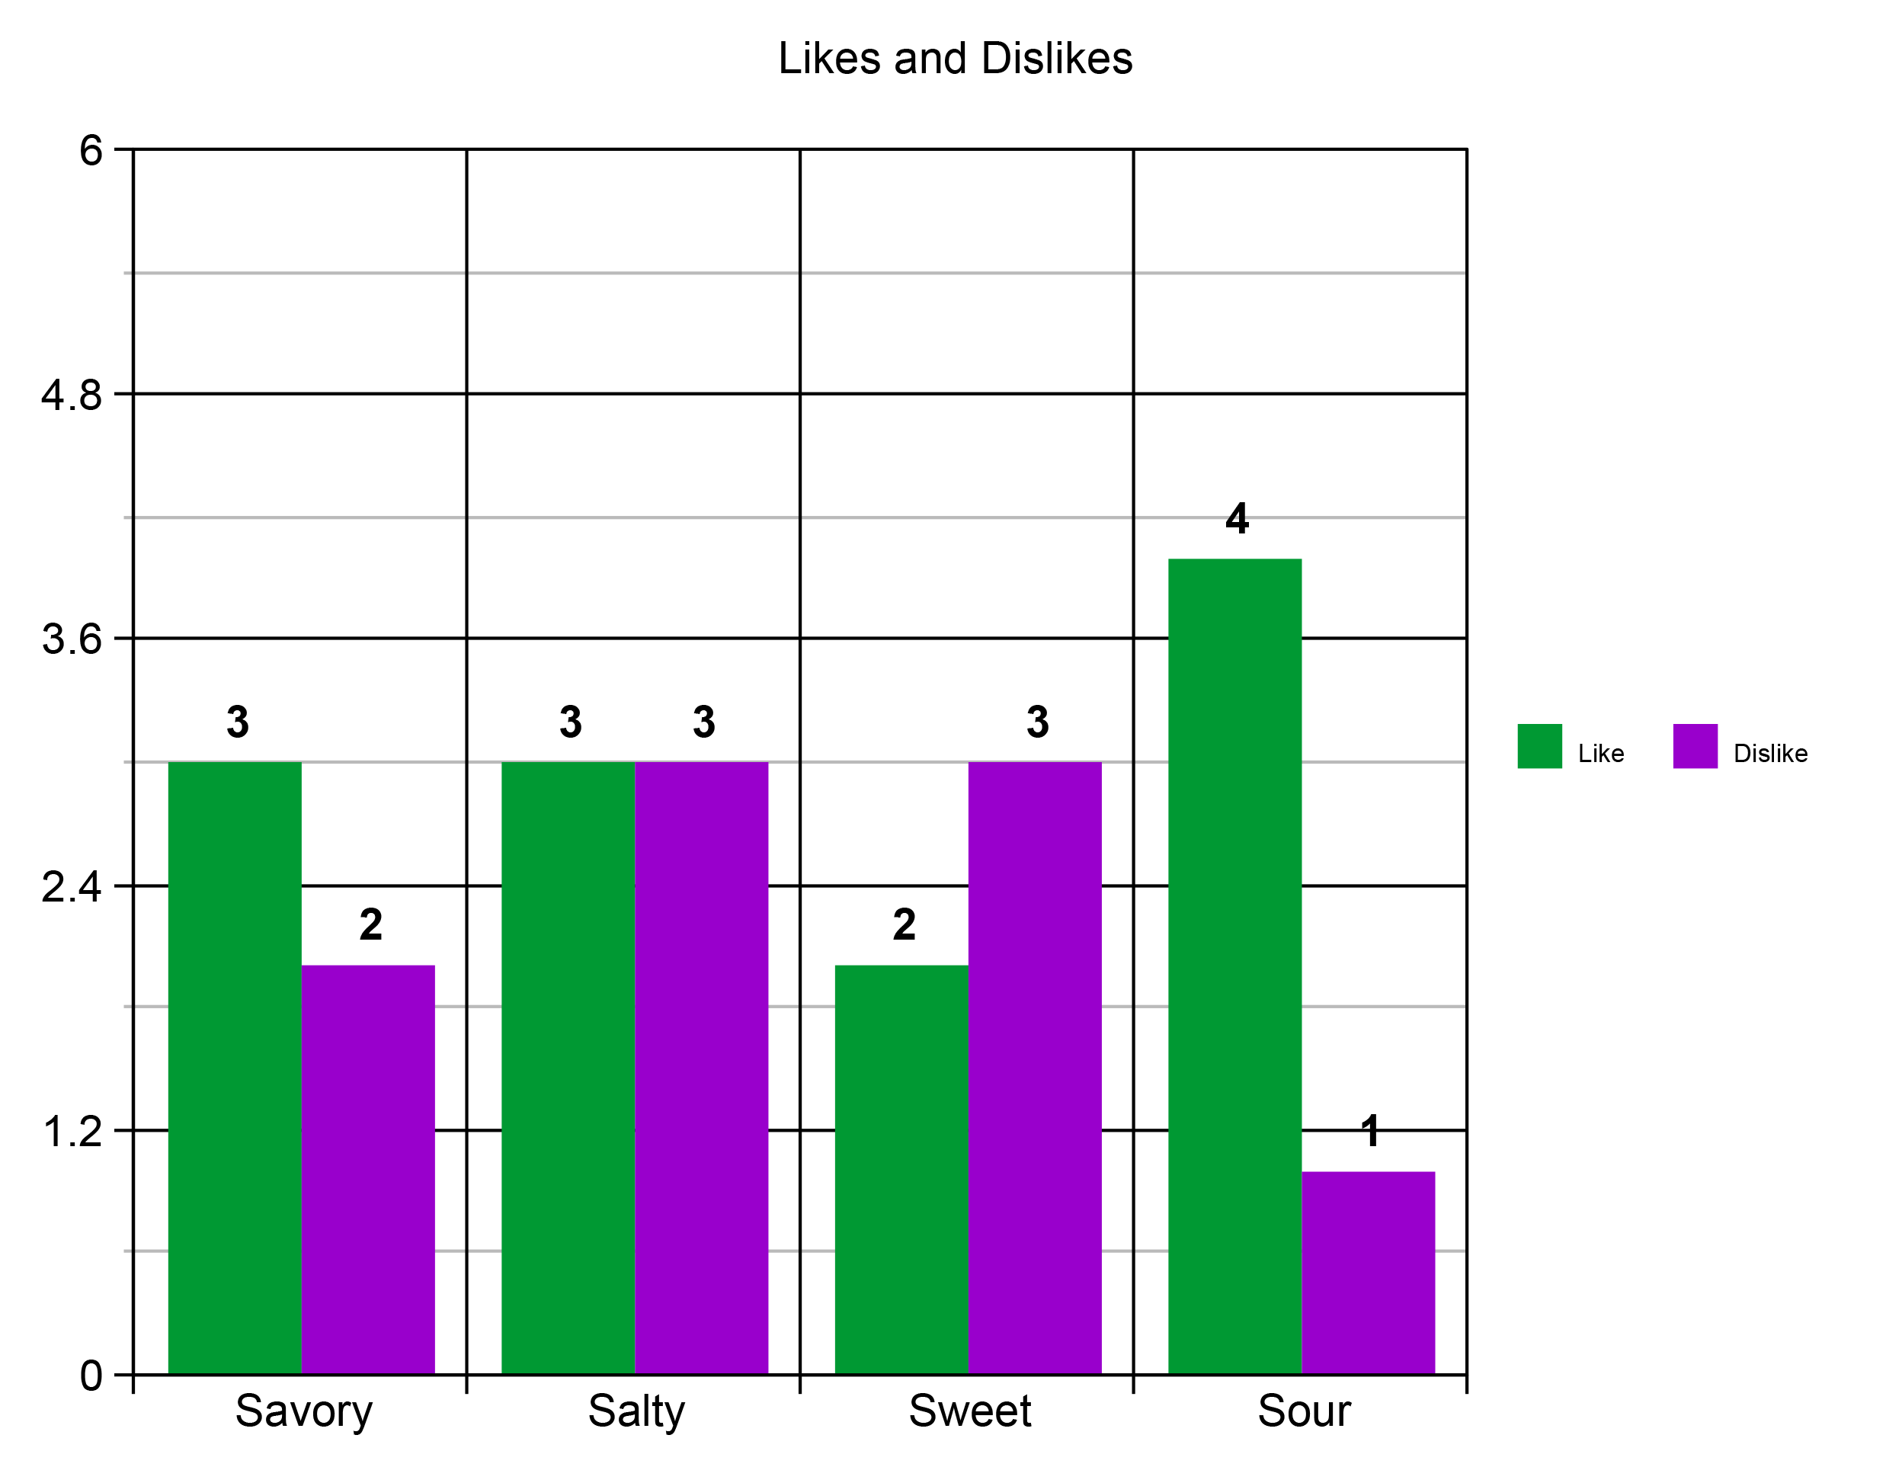

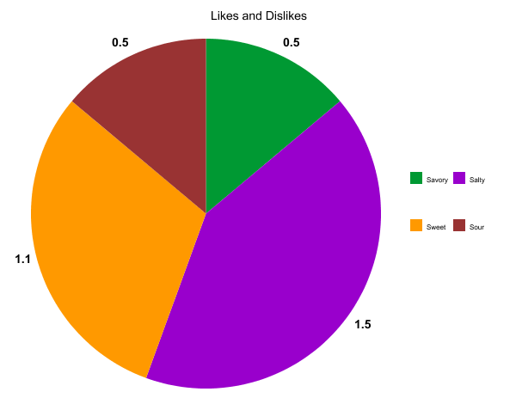

*\*Prices of stock are balanced based off these graphs.*

1 stock counts for 10 purchases from AIs.

***Savory*** 1 stock 200, sells for 50 each, total 500

***Salty*** 1 stock 200, sells for 350 each, total 350

***Sweet*** 1 stock 200, sells for 400 each, total 400

***Sour*** 1 stock 200, sells for 80 each, total 800